**Load Different Style Sheet Dynamically**

This is an Example to Load Different Style Sheet Dynamically on the Component in React Native. To do this we will use a conditional operator and state. When we change the state view will re-render itself and after checking the state we will change the style of the component. In this example, we are using Text as our component and will change the style of a Text.

Load Different Style Sheet Dynamically on the Component Using

style={this.state.isOldStyle === true ? styles.stylOld : styles.styleNew}

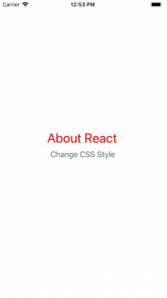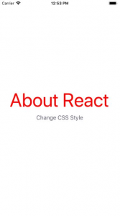

/*This is an Example to Load Different CSS Style in React Native on View Component */

import React, { Component } from 'react';

import { StyleSheet, View, Button, Text } from 'react-native';

export default class App extends Component {

constructor() {

super();

this.state = {

isOldStyle: true,

};

}

ChangeNewStyle = () => {

this.setState({

isOldStyle: false,

});

};

render() {

return (

<View style={styles.MainContainer}>

<Text

//Here we are setting the style on the basis of state

style={this.state.isOldStyle === true ? styles.stylOld : styles.styleNew}>

About React

</Text>

<Button

title="Change CSS Style"

onPress={this.ChangeNewStyle}

color="#606070"

/>

</View>

);

}

}

const styles = StyleSheet.create({

MainContainer: {

justifyContent: 'center',

alignItems: 'center',

flex: 1,

margin: 10,

},

stylOld: {

fontSize:30,

color:'red'

},

styleNew: {

fontSize:60,

color:'red'

},

});